CS 255 System Design Document – DriverPass

UML Use Case Diagram
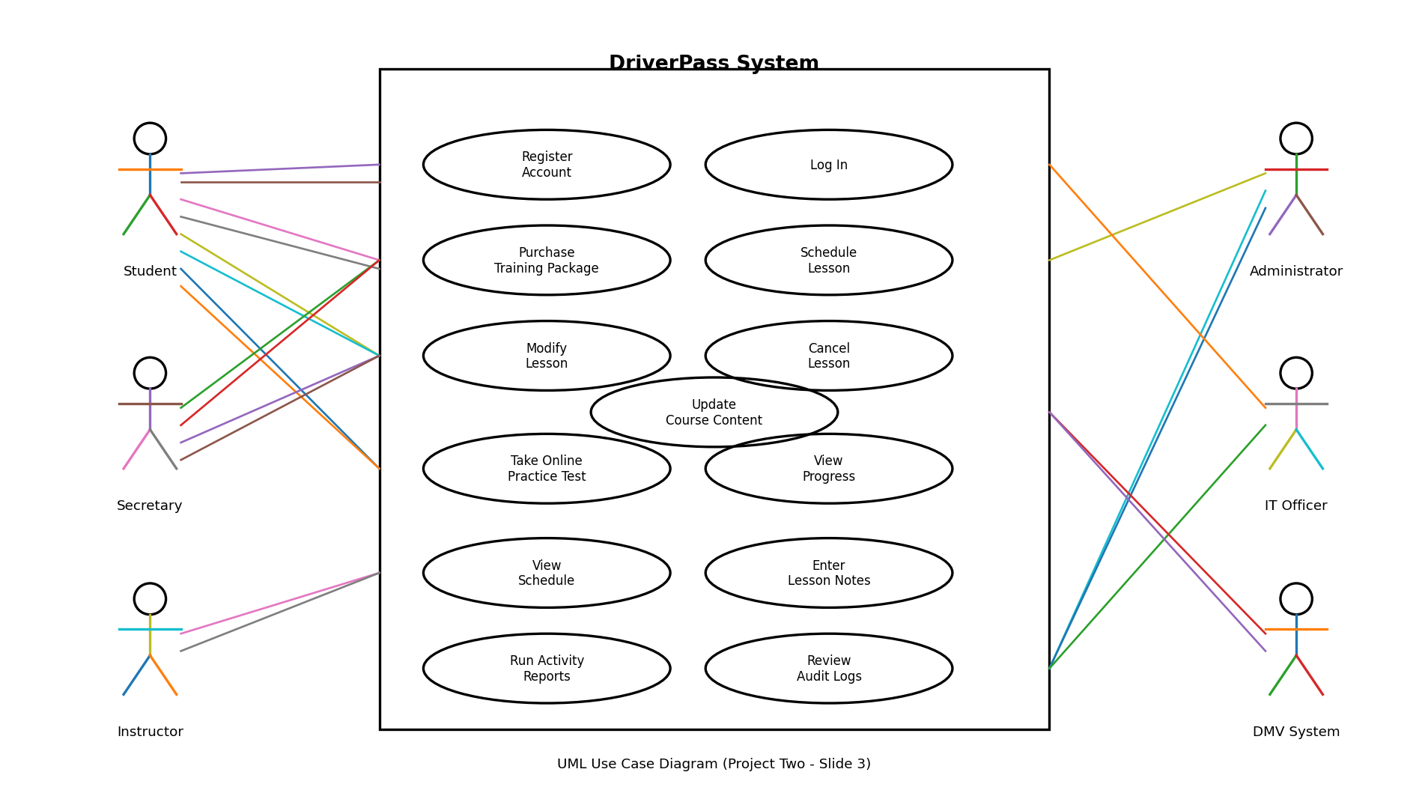
The UML use case diagram illustrates how different users interact with the DriverPass system. Students can register, log in, purchase training packages, schedule driving lessons, take practice tests, and track their progress. Secretaries assist with scheduling, instructors manage lesson notes, administrators review system activity, and the DMV system provides updated testing content.

UML Activity Diagrams
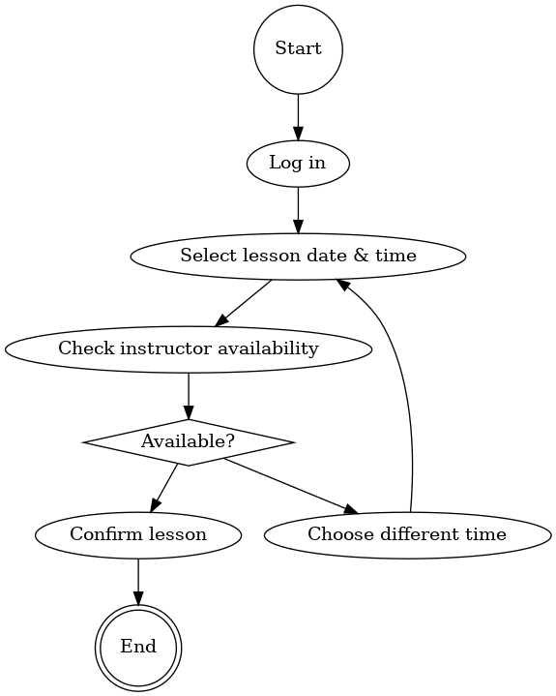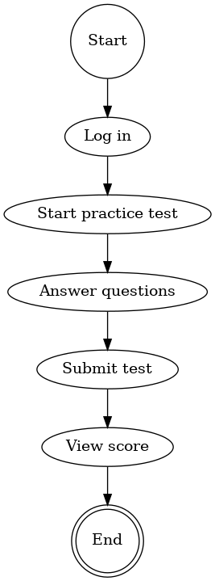

The activity diagrams show the step-by-step flow of key system processes. The lesson scheduling diagram demonstrates how a user selects a time and receives confirmation, while the practice test diagram shows how a student completes and submits an online test.

UML Sequence Diagram
The sequence diagram shows how system components communicate during lesson scheduling. It highlights the order of interactions between the student, system interface, and scheduling services.

UML Class Diagram
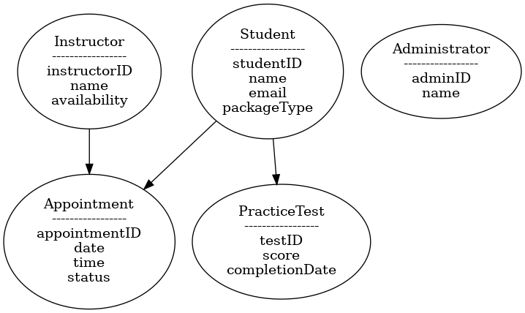
The class diagram outlines the main data structures used in the DriverPass system, including students, instructors, appointments, practice tests, and administrators. This structure supports data organization and system scalability.

Technical Requirements
The DriverPass system will operate as a web-based application accessible through modern browsers on desktop and mobile devices. A secure cloud server will host the application and store user, scheduling, and testing data. The system will use role-based authentication and encrypted data storage to protect sensitive information. An external DMV connection will provide updated rules and practice test content, while regular backups ensure reliability.

